**Java Rice**

**An Interactive Food Ordering System**

@BSCS1A

SY: 2022-2023

About Us:



**Kurt Daniel S. Cano**

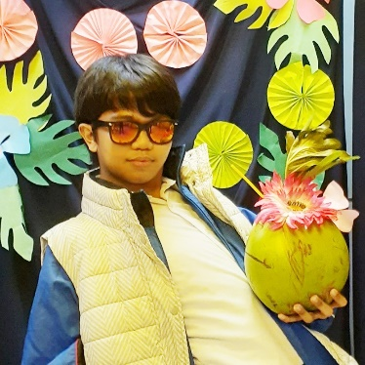

**Mike Rufino J. Caram II**



**Joshua O. Lonoza**



**Kevin A. Llanes**



**Jhon Keneth Ryan B. Namias**

"Now you'll Meat your End." -Vergil

Table of Contents: *update when necessary*

Contents

About Us: 1

Table of Contents: *update when necessary* 1

I. Introduction: 3

II. Objectives: 3

III. Methodology: 3

IV. Timeline: 3

V. Limitations: 3

VI. Criteria: 3

VII. Conclusion: 3

VIII. References: 4

IX. Appendix: 4

X. Flowchart: 4

XI. Changelog (Prototype) 5

Alpha Build 1: February 3, 2023 - February 11, 2023 5

i. UI and Logo Design: 5

ii. Database: 9

iii. Forms: 11

iv. Functions: 11

v. Color Palette: 11

vi. References for Databases: 11

Alpha Build 2: February 12, 2023 - February 23, 2023 14

I. Measurement: 14

II. Font: 14

III. Database (Excel) 15

Alpha Build 3: March 07, 2023 - March 11, 2023 15

I. Header3: 15

Beta Build 1: 15

Release Build: 15

I. Introduction:

Java Rice is a food ordering system designed to make the process of ordering food easier for users. The system is built using Java and Maven GUI, which provides an interactive and user-friendly experience. The purpose of this system is to allow users to order their favorite meals with ease and convenience.

II. Objectives:

* To provide a platform where users can order food with just a few clicks.
* To make the process of food ordering fast and efficient.
* To provide users with an interactive and user-friendly experience.
* To provide a secure and reliable platform for food ordering.

III. Methodology:

* The system will be built using Java programming language and Maven GUI for the front-end interface.
* A database will be used to store all the information about the food items and orders.
* The system will provide a user-friendly interface for users to place their orders.
* The system will use secure payment methods to process the transactions.

IV. Timeline:

* Planning and Design Phase: 2 weeks
* Development Phase: 4 weeks
* Testing and Debugging Phase: 2 weeks
* Deployment Phase: 1 week

V. Limitations:

* The system will only be available for use on devices with Java and Maven GUI installed.
* The system will only support online payment methods.
* The system will not provide delivery services.

VI. Criteria:

* Usability
* Availability
* Reliability
* Maintainability
* Security

VII. Conclusion:

Java Rice is a food ordering system designed to provide users with a fast and convenient way to order food. The system is built using Java and Maven GUI, which provides an interactive and user-friendly experience. The system will provide a secure platform for food ordering and will be accessible on devices with Java and Maven GUI installed. The estimated timeline is 9 weeks.

VIII. References:

* Java Programming Language Reference: Oracle Corporation
* Maven GUI Reference: Apache Software Foundation
* <https://PP-Namias.Github.io/Java-GUI/>

IX. Appendix:

* Detailed project plan
* Technical specifications
* UI Design
* Database

X. Flowchart:

XI. Changelog (Prototype)

*This is compilation and record of development progress and notable changes made from inside-out and start-to-finish of the program or also known as changelogs.*

Alpha Build 1: February 3, 2023 - February 11, 2023

**Planning and Designing Phase**, this week's development progress will be focused on finding references, brainstorming, and planning for program design, as well as making the most of available time to ensure efficient and progressive coding in subsequent weeks.

The Plan is to make a structure of what program will be created, it includes the design of possible future User Interface of the program that will be used for referencing and on top of that is to brainstorm a plan as well as Logo Designing.

Changes included on the program as follows:

i. UI and Logo Design:

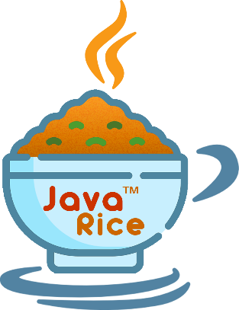

Java Rice Logo [Transparent]



Java Rice Banner with Logo [Transparent]



Java Rice Banner [Transparent]

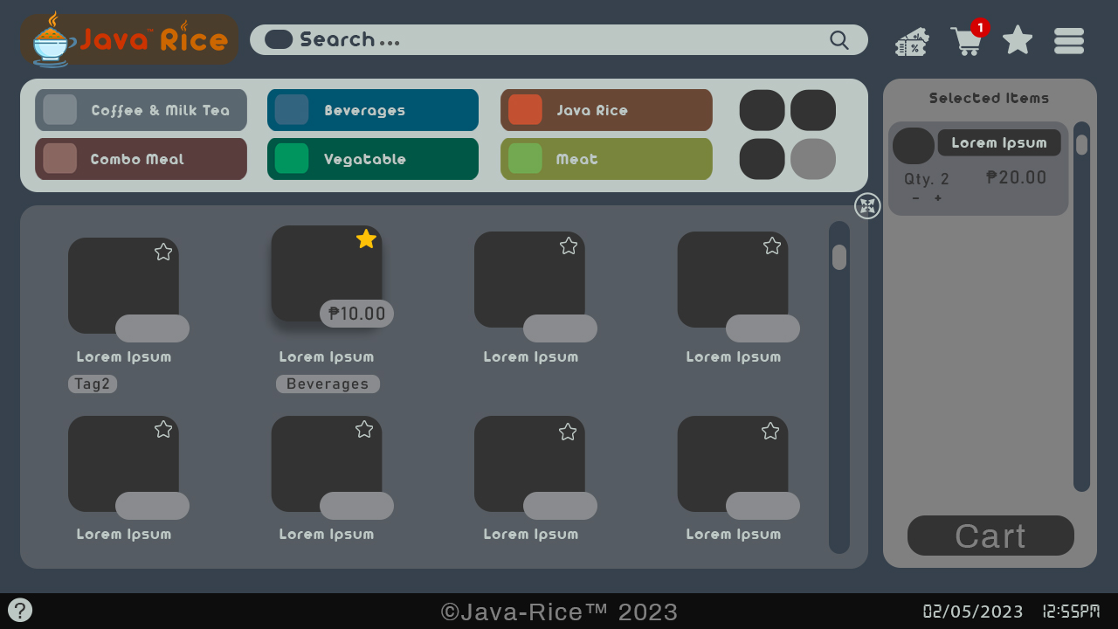

Java Rice Main Form [Regular]

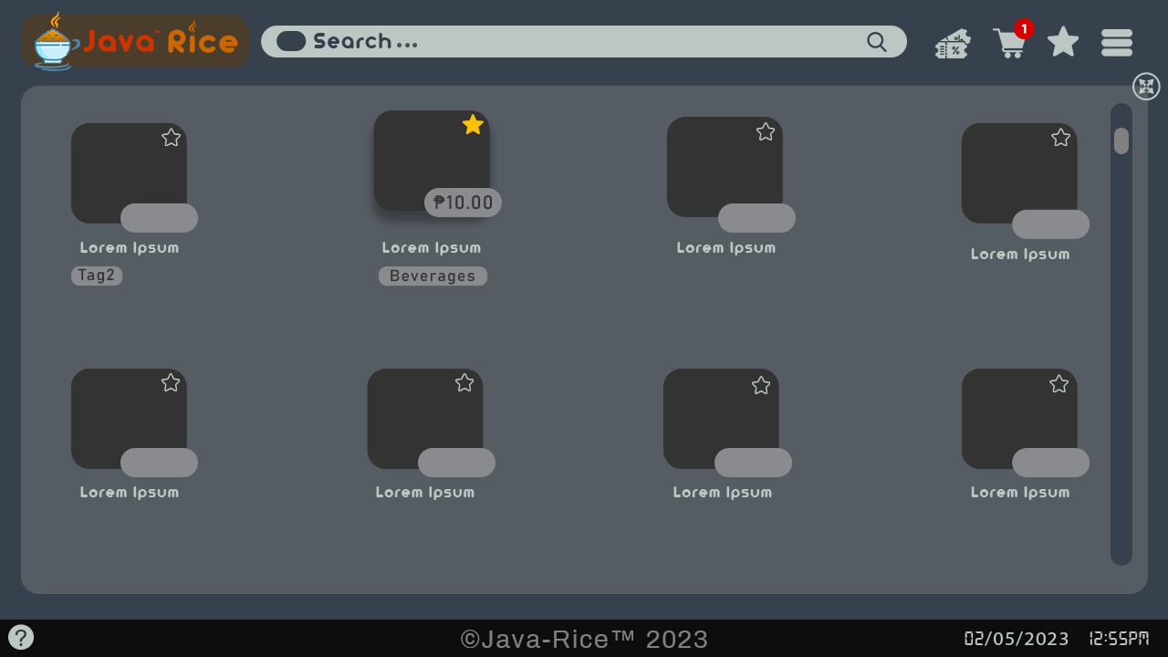

Java Rice Main Form [Maximize]

**

Java Rice Receipt [Default] Java Rice Receipt [Example]

ii. Database:

CREATE TABLE IF NOT EXISTS **Products** (

**Product_ID** SERIAL NOT NULL PRIMARY KEY,

**Name** TEXT NOT NULL,

**Category** TEXT NOT NULL,

**Store_num** TEXT NOT NULL,

**Price** DOUBLE PRECISION NOT NULL,

**Image** OBJ NOT NULL,

**Popular** BOOL NOT NULL

);

CREATE TABLE IF NOT EXISTS **Cart** (

**Product_ID** SERIAL NOT NULL PRIMARY KEY,

**Name** TEXT NOT NULL,

**Category** TEXT NOT NULL,

**Store_num** TEXT NOT NULL,

**Price** DOUBLE PRECISION NOT NULL,

**Image** OBJ NOT NULL,

**Quantity** INT NOT NULL,

**Voucher** TEXT NOT NULL,

**Discount** DOUBLE NOT NULL

);

CREATE TABLE IF NOT EXISTS **Order** (

**Order_ID** SERIAL NOT NULL PRIMARY KEY,

**Product_ID** SERIAL NOT NULL,

**Name** TEXT NOT NULL,

**Category** TEXT NOT NULL,

**Store_num** TEXT NOT NULL,

**Price** DOUBLE PRECISION NOT NULL,

**Image** OBJ NOT NULL,

**Quantity** INT NOT NULL,

**Voucher** TEXT NOT NULL,

**Discount** DOUBLE NOT NULL

);

CREATE TABLE IF NOT EXISTS **Sales** (

**Order_ID** SERIAL NOT NULL PRIMARY KEY,

**Product_ID** SERIAL NOT NULL,

**Category** TEXT NOT NULL,

**Store_num** TEXT NOT NULL,

**Quantity** INT NOT NULL,

**Date_processed** DATE NOT NULL,

**Profit** DOUBLE NOT NULL

);

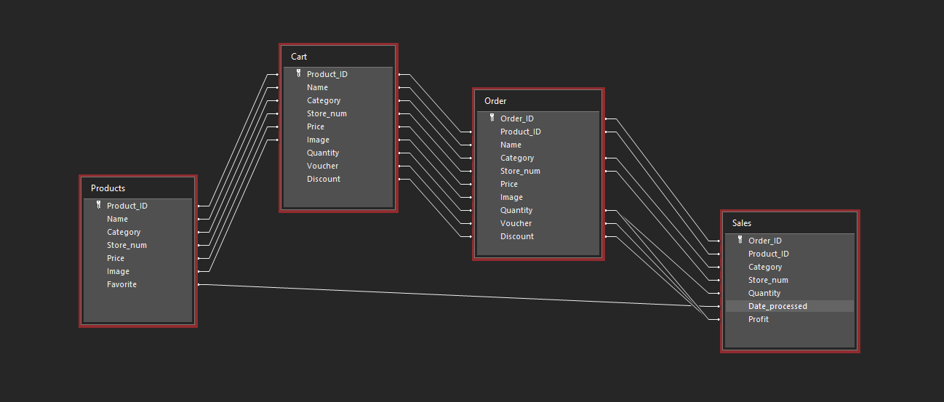

iii. Forms:

* MainForm
* DeveloperForm
* Cart
* Receipt

iv. Functions:

* Ordering system [Multiple Selections]
* Auto-generated search bar
* Receipt
* Order logs
* Items order
* Order number
* QR Code [Generator] [Reader]
* Voucher Discounts

v. Color Palette:

* **Main Background:** #36414d rgb(54, 65, 77)
* **Foreground:** #898b8e rgb(137, 139, 142)
* **Text (Dark):** #36414d // Light Background rgb(54, 65, 77)
* **Text (Light):** #bcc7c4 // Dark Background rgb(188, 199, 196)
* **Other:**
  + #333333 rgb(51, 51, 51)
  + #5182a1 rgb(81, 130, 161)
* **Cart:** #808080
  + #63656a rgb(99, 101, 106)
* **Footer:** #0d0d0d rgb(13, 13, 13)
* **Logo:**
  + #cc3300 // Java rgb(204, 51, 0)
  + #cc6600 // Rice rgb(204, 102, 0)

vi. References for Databases:

**Store: [Name]#_**

**1. Maestro Food Hub {Meal}**

**2. Garvs' PaKanton {Noodles}**

**3. Bam-bam's {Meal}**

**4. Snap n' Bite {Snacks, [Fries, Burger, Hotdogs, Donuts]}**

**5. RMBSJ: Tapsilogan ATB. {Set Meal}**

**6. Kuya Lery: Pares ng Bayan {Noodles, Pares, Mami}**

**7. Shake It Off {Snacks, Milk Tea, Shakes}**

**8. Kitchen Nanay {Snacks, Meal}**

**9. SnowJoe {Ice Cream, Cold Drinks}**

**10. Happy Tummy {Set Meal, Noodles}**

**Food Price: ####.##**

**Products: [ProductName]**

**Food Category:**

* + **Beverages** {Cola, Softdrinks, Tea, Coffee, Milk, Energy Drink, Hot Chocolate, Milk Tea (sub categ.?), Water, Juice}
  + **Combo Meal** {Rice + 2 dish, e.g.: Rice + Vegetable + Meat, or any combo}
  + **Vegetables** { Adobong Kang-kong, Pinakbet, Ginataang Kalabasa, Lumpiang Togue, Ginisang Togue, …}
  + **Meat** {Curry, Adobo, Bicol Express, Fried Chicken, …}
  + **Fish** {Paksiw, Fried Fish, Lumpiang Shanghai, …}
  + **Snacks** {Bananacue, Ginataang Bilo-bilo, Turon, …}
  + **Noodles** {Palabok, Pancit Bihon, Spaghetti, Pares, Mami, Lomi, Fried Noodles, Pancit Canton, Cup Noodles}
  + **Milk Tea** { }

I. Maestro Foodhub (meal)

* meat vegetable combo
* siomai rice
* sizzling sisig
* sizzling burger steak

II. Garvs kantuhan (Noodles)

* Fried Noodles Hongkong Style Plain (Special 35php)
* Fried Noodles with egg (45php)
* Fried Noodles with pork siomai (45php)
* Fried Noodles with sharkfin (45php)
* Fried Noodles with beef (50php)
* Pork Ramen (70php)

III. Bam-bam's (meal)

* sizzling hotdog
* sizzling sisig
* sizzling burger steak
* spaghetti

IV. Snap n' Bite (meal & snacks)

* sharksfin - 29
* pork siomai - 29
* gyoza - 29
* lumpiang shanghai - 29
* java rice meal - 39
* java rice meal + 12 oz drink - 49
* 12oz drink - 15
* 16oz drink - 19
* corndog bits
* corndog

V. RMBSJ (Set meal)

* Hotsilog - 45
* Skinsilog - 45
* Hamsilog -45
* siomaisilog - 45
* embosilog - 45
* cornsilog - 50
* tapsiloc - 55
* chorizosilog - 45

VI. Kuya Lery (Noodles)

* Pares - 35
* Pares with rice - 45
* Mami - 30
* Mami with rice - 40

VII. Shake it off (Snacks, Milk Tea, Shakes)

* Snacks
* hamburger
* hamburger w/egg
* real cheese sticks
* fries & hotdog w/ juice
* fries w/juice
* fries
* footlong w/ cheese
* half-long w/ cheese
* Shakes
* mango
* cookies and cream

VIII. Kitchen Nanay (Snacks, Meals)

IX. Snowjoe (Ice cream, cold drinks)

* milk melon popsicle stick (Specialty 12Php)
* Watermelon popsicle stick (12Php)
* Chocolate mochi ice cream (13Php)
* Cola 237mL(11Php)
* Soda 237mL(11Php)
* Lemon juice (15Php)
* Orange juice (15Php)

X. Happy Tummy (set meal, noodles)

* Milk tea
* Fruit tea
* pork sisig
* fried noodles
* fried noodles w/egg
* fried noodles w/ siomai

Alpha Build 2: February 12, 2023 - February 23, 2023

**Development Phase,**

I. Measurement:

* **Footer**: 1280 x 41
* **Main** **Product** **Window**: 971 x 416
* **Category** **Background**: 971 x 130

**Category** **Rectangle**: 243 x 48

**Category** **Quad** **Box**: 52 x 47

* **Cart** **Side** **Bar** **Background**: 245 x 560

**Cart** **Item**: 205 x 110

**Cart** **Button**: 190 x 45

* **Search** **Bar**: 707 x 286
* **Logo**: 250 x 58

II. Font:

* **Archivo**
* **Arista**
* **Bahnschrift**
* **Myriad Pro**

III. Database (Excel)

[Database - JavaRice.xlsx](https://1drv.ms/x/s!Am1JvRELYZ5OkV9SVXW56iUcIV7i?e=5Fuzis)  
https://1drv.ms/x/s!Am1JvRELYZ5OkV9SVXW56iUcIV7i?e=5Fuzis

Alpha Build 3: March 07, 2023 - March 14, 2023

**Project Proposal Phase,**

I. Flowchart:

## [Java Rice - Flowchart](https://app.diagrams.net/#G1ZGDTAsyz7gXRBDC9jFvqEyyFOlZb3GWO)

#### https://app.diagrams.net/#G1ZGDTAsyz7gXRBDC9jFvqEyyFOlZb3GWO

II. Proposal Powerpoint:

III. Proposal Summary:

***One Client (Stall)***

***Payment***

***Users***

***Admin***

***Public***

Beta Build 1:

**Testing, and Trial Run / Debugging Phase**

Release Build:

**Deployment Phase**, final.